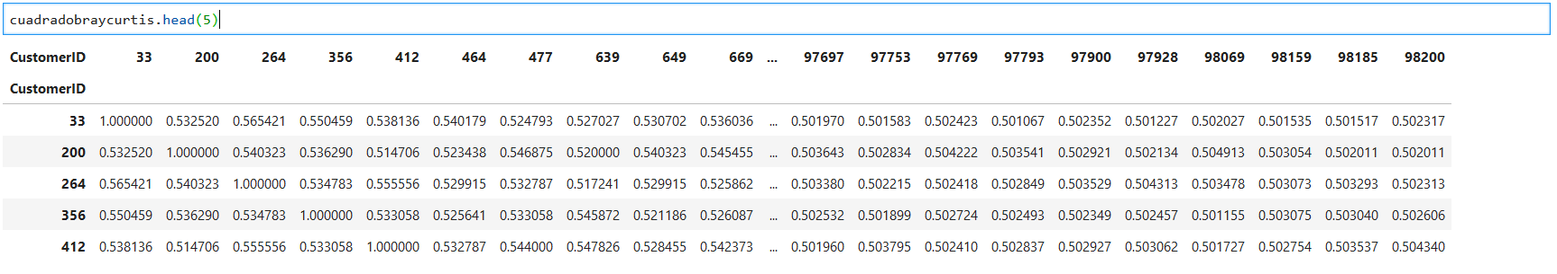

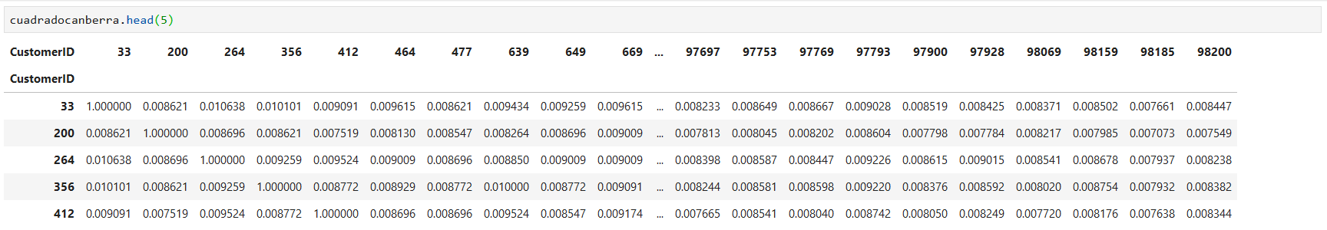

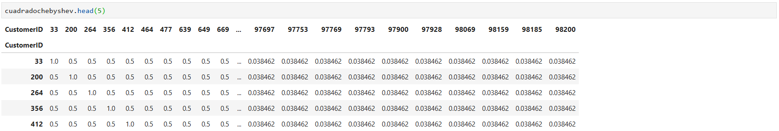

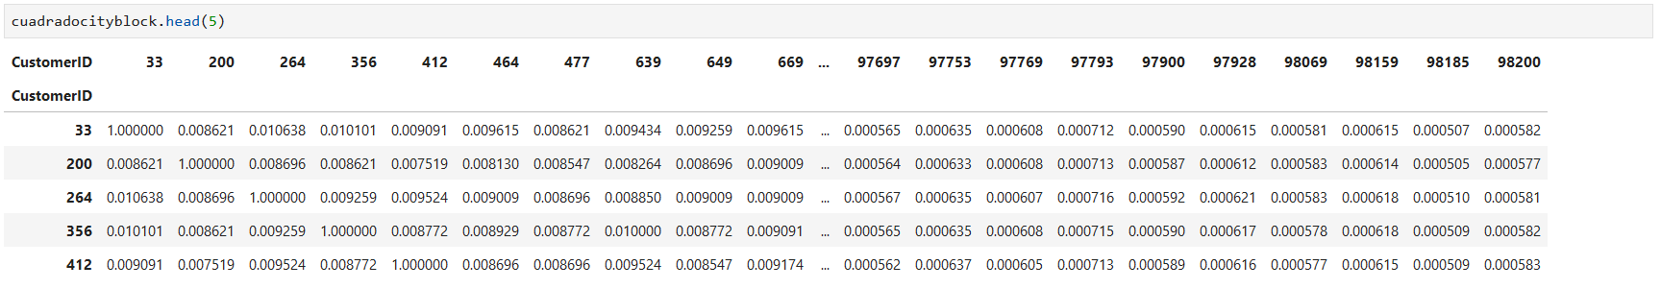

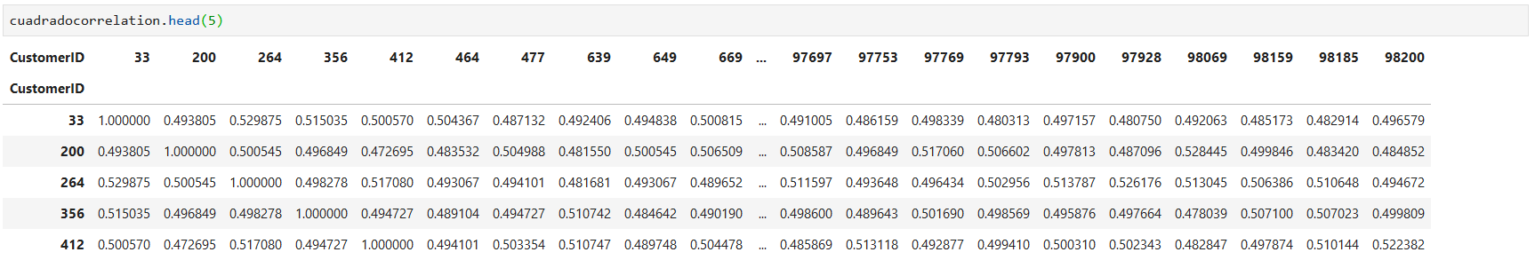

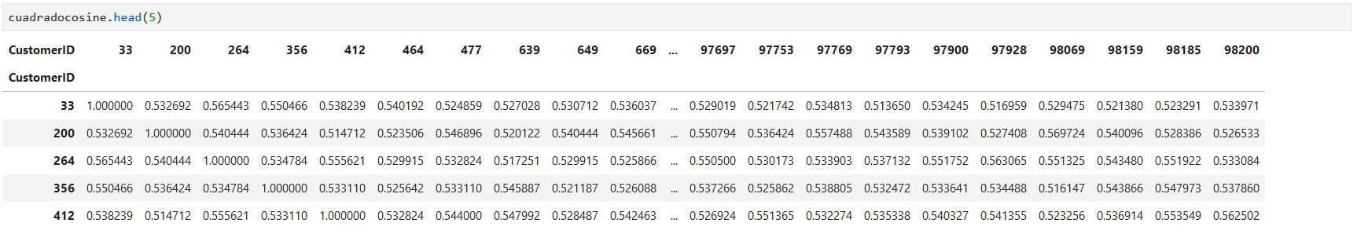

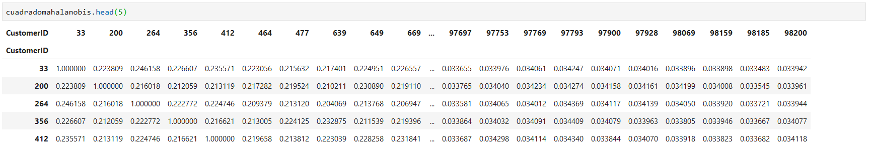

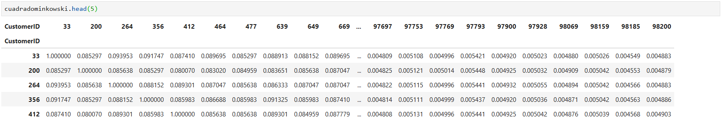

33 braycurtis

[1577, 264, 3531, 3909, 756]

33 canberra

[10016, 3909, 14913, 4261, 264]

33 chebyshev

[2187, 2503, 2556, 2566, 2582]

33 cityblock

[3909, 264, 3531, 2503, 3305]

33 correlation

[10016, 27672, 45786, 38265, 5224]

33 cosine

[27672, 10016, 60862, 76532, 85766]

33 mahalanobis

[264, 3535, 2187, 3317, 756]

33 minkowski

[3909, 3531, 264, 2503, 3305]